South Calgary Primary Care Network Pain Program
Handbook

Table of Contents – Pain Program Handbook
Part 1: Getting Started 5
- PART A: 6
- What is the South Calgary Primary Care Network? 6
- What is the SCPCN Pain Program? 6
- The SCPCN Approach 7
- 8
- The SCPCN Pain Program does NOT: 8
- How will my family doctor be involved? 9
- 9
- 9
- PART B: A New Way Forward 10
- Tame the Beast Video 10
- 10
- Introduction to Pain Education 11
- Introduction to Top Priority Planning 14
Part 3: Preparing for Your Team Appointments 17
- PART A: What YOU can expect from us: 18
- What WE expect from you: 18
- Part B: Who are the Team Members? 19
Part 4: Final Check-In 24
- Starting Your Journey: Readiness Checklist 24

For Your Information (FYI)
A few helpful hints to guide YOU

- What is the Health History Review? This will be your first appointment when you start with the Pain Program. This visit will gather information about your health, pain history, and work with you to choose your goals, and plan next steps.
- Who are the MOAs (medical office assistants)? The MOAs support the clinic in many ways. You will talk to the MOAs to manage your appointments including booking, rescheduling, or cancelling.
- What if I have questions? You may call the Wellness Centre at 403-668-8600 option 1 during clinic hours to speak with a MOA.
- What if I change my family doctor? Notify the SCPCN as soon as possible if you have a new family doctor. You can do this by calling to speak with our MOA or letting us know at any appointment with the team.

Introduction
This handbook acts as resource for the SCPCN Pain Program. It provides some overview of the clinic and what to expect during your visits. It also provides some general information on persistent pain and common approaches for its management. In this package, you will find the following worksheets to review prior to your health history review.
  - Patient Reflection worksheet
  - Self-Management worksheet

Part 1: Getting Started

- Here you will be introduced to the Pain Program and how we approach managing chronic pain.
- Next, there is a short introduction to pain education. Please also consider reading the Tazzy Understanding Persistent Pain Booklet for additional, helpful information about pain. This is an additional resource that can be found on the website, however, is not necessary to be printed. You can find this booklet at: https://tinyurl.com/58t6vmkx
During this introduction, we will ask you some questions to get you thinking about areas of your life you want to focus on during your journey with the program.

PART A:

What is the South Calgary Primary Care Network?

South Calgary PCN is a network of doctors and other health providers such as nurses, dietitians, kinesiologists, pharmacists, social workers, and mental health therapists working together to provide excellent healthcare to people in South Calgary.

What is the SCPCN Pain Program?

This program has been designed to provide patients with chronic pain additional supports and interventions to better enable effective chronic pain management. The program places emphasis on patient-centered care by identifying:
- Personalized top priorities in chronic pain management
- Promoting self-management care
- Developing effective coping strategies
These will all be identified through participation in program workshops and working closely with the multidisciplinary team.

Your team will consist of:
- Licensed Practical Nurse | - Mental Health Therapist
- Kinesiologist | - Physician
- Pharmacist | - Health Specialists (as required)

As you work through the program, building a strong foundation on effective pain management will be the focus. This will be achieved through accessing a variety of program resources:

The SCPCN Approach

At the Pain Program, you will learn how to manage chronic pain and improve function with:
- A New Perspective: Manage instead of cure.
- A New Goal: Improve function & quality of life.
- A New Focus: Cope positively with pain.

Our purpose is to EMPOWER and INSPIRE individuals with chronic/persistent pain by improving their quality of life

The SCPCN Pain Program does NOT:

Provide a pain diagnosis, surgical consultations, second opinions, massages, chiropractic services, interventions such as injections and legal or insurance reports.

How will my family doctor be involved?
- We at the SCPCN will work together with your family doctor and PCBH provider to manage your pain and provide your doctor with updates about your progress.
- The SCPCN will not take over prescribing your medications. You will continue to see your family doctor for routine care, including prescription refills, and for any changes to your health.
- Please let the SCPCN know if you change your family doctor.

PART B: A New Way Forward

If you have had chronic pain for a long time, you have likely tried a lot of different things to get better. The SCPCN Pain Program way of managing chronic pain may be different from what you have done before. To change your pain experience, prepare to learn new information and think differently about pain.

Tame the Beast Video

For a new understanding of chronic pain, watch “Tame the Beast” (5 minutes), which can be found at www.tamethebeast.org

Think about these questions after watching “Tame the Beast”:

- What do you think about the beast? _________________________________________________________________________________________________________________________________________________________
- How does your experience with pain compare to what you saw in “Tame the Beast?”
_________________________________________________________________________________________________________________________________________________________
- What is something new you learned about pain? _________________________________________________________________________________________________________________________________________________________

Introduction to Pain Education

What is pain exactly?
Pain is defined as “an unpleasant sensory and emotional experience associated with actual or potential tissue damage or described in terms of such damage” (IASP, 2017).

Icon made by Flat Icons from www.flaticon.com

How does acute pain compare to chronic pain?
Chronic pain is not just acute pain that lasts longer. Pain that lasts longer after tissues have healed involves your nervous system being over-protective. With chronic pain, we need a different approach.
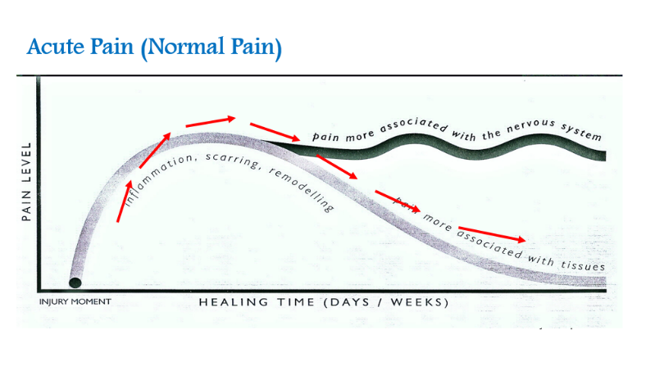

From “Tame the Beast”, pain is not providing an accurate measure of tissue health. Pain is a protector!
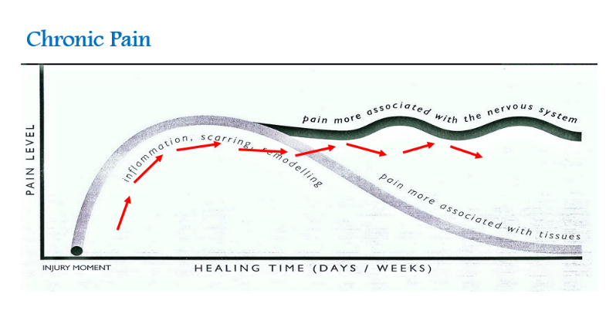

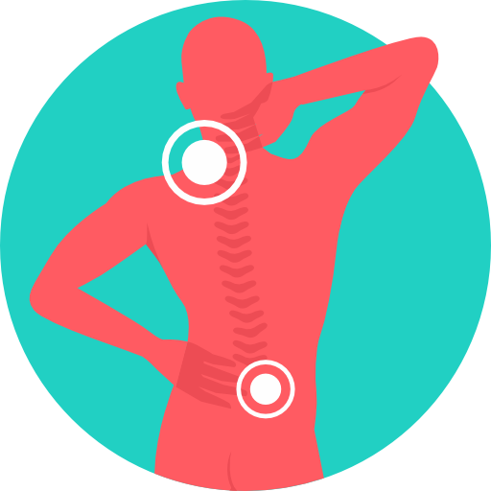
- Pain is like your body’s “alarm system” and can become over-protective.
- Pain leads to more pain! Again from “Tame the Beast” video, your body learns more pain.
(www.tamethebeast.org)

Pain is like an alarm system that protects you from harm or possible harm.
:

Pain is not just about the body part that hurts. Coping with pain means looking at the Big Picture of YOUR Life.

Mind Body Connection
Pain is influenced by many aspects of your life — they are all connected. An improvement in one area can also help in other areas!
- What we feel affects what we think and do
- What we think affects how we act and feel
- What we do affects how we think and feel

Part 2: Preparing for your Visits
- This section of the handbook will support you during your visits. You may find it useful to have this booklet with you in your Pain Program appointments.
- During your visits with team, you will have an initial assessment with each provider that pertains to their specialty. At future visits, we will build upon these visits and establish goals that are specific to your personal pain journey to optimize your quality of life and improve function. During these visits, consider the following suggestions:
  - Keep a pen and paper with you in case you want to jot down notes.
  - Find a place where you feel safe, comfortable, and have privacy to talk about your health.
  - Have a glass of water nearby in case you get thirsty.
  - Plus, have anything else you might need to be comfortable.

What is most important?
YOU are in the centre and YOU are actively involved.

Introduction to Top Priority Planning

Setting meaningful goals is a key part of your journey. When you meet with different team members, you will receive support to set these priorities.
It is important to set priorities with the right approach. It is easy to be too general or focus too much on the end-result rather than the steps you take to get there. You will learn techniques that will help guide your priorities and make them goal specific that includes creating an action plan.

Examples of helpful versus unhelpful goals
Unhelpful goals:
- “I want to exercise more” (too general).
- “I want to get rid of my pain.” (too focused on pain and not on taking steps to improve daily life).

Icon made by Pixel Perfect from www.flaticon.com

- “I will use pacing to add (a favorite hobby) back to my routine starting with 10 minutes three days per week for one month.”
- “I will practice at least two stretches every day this week.”

Helpful goals:

Icon made by Kiranshastry from www.flaticon.com

Top Tips for Goal Setting

It’s important to keep these tips in mind when choosing your goals for managing pain.
Top 3 Tips for Goal Setting

- Focus on your function rather than a cure.
- Keep it realistic and practical. Focus on quality of life.
- Prioritize areas where you can build your confidence.

Icon made by Freepik from www.flaticon.com

Goals for Improving My Daily Life
My most important goals: E.g. I will start by taking my dog for a walk for 5 minutes in the morning 3 days per week over the next two weeks. ____________________________________________________________________________________________________________________________________________________________________________________________________________________________________________________________________________________________________________________________________________________________________________________________________________________________________

Top tip for goal setting: Focus on improving function to change your pain.
Icon made by Freepik from www.flaticon.com

Part 3: Preparing for Your Team Appointments

The focus of the SCPCN Pain Program is to provide you with tools to help improve your function in everyday life. In Part 3 we will cover the following info:
- What you can expect from us and what we expect from you.
- Meet the SCPCN team.

PART A: What YOU can expect from us:

- Professional, passionate, and enthusiastic.
- Experienced with chronic pain.
- We will meet you where you are at.

What WE expect from you:

- You are actively involved.
- It is important to attend your appointments. We have a “no show” policy requiring at least 24 hrs notice to cancel an appointment.
- Stay connected. If you haven’t met with any SCPCN team members for one month and do not have any future appointments scheduled, please call the Wellness Centre.
- Let us know if you have a new family doctor or if your doctor moves to a new clinic location.

Part B: Who are the Team Members?

Get to know the SCPCN Team. Here is a list of team members and how they can help you add tools to your pain management toolbox. You will have the opportunity to meet them, and also connect with other support team members based on your priorities. It is important to note that participation in the program involves the entire multidisciplinary team and is not intended to be used to access only a single provider.

Licensed Practical Nurse
The Licensed Practical Nurse (LPN) will complete your initial intake and help you navigate appointments with other providers to ensure you are getting the right care. The LPN can help you learn how to manage your pain from day-to-day.

Pharmacist
It is essential to understand how to use medications safely and effectively to manage your pain. Our pharmacist will help you learn more about pain and how medications may help improve function or reduce pain levels. You can discuss the best timing, special considerations, and other points about your medications. While medications are a piece of the puzzle, they are not the only way to support you living with pain, so the pharmacist will work with other team members and your family doctor to support your goals.

Kinesiologist
Movement is an essential part of living better with chronic pain. If you have tried to be more active but struggled with pain flare-ups, fear of movement, low motivation, or sticking with a routine, working with our kinesiologist will help you to overcome these challenges and get back to activities you enjoy.

Mental Health Therapist
Chronic pain is not just about the body part that hurts. Working with a mental health therapist can help you understand your pain and build hope. Learn to manage thoughts, feelings and past experiences that might be influencing your pain, as well as techniques to reduce pain perception and accept pain without suffering. They will also support you to improve your function with pain while building resilience, recovering faster from set-backs, and experiencing personal growth.

Physician
The physician will work alongside with the pain team (your GP, PCBH, Pharmacist, Mental Health Provider, Kinesiologist and LPN) to provide further consultation and collaborate with the team on best management options that are personalized for you. Treatment plans are always based on your readiness and involvement.

ADDITIONAL SUPPORTS AVAILABLE AT THE SCPCN
Through your medical home, you also have access to a network of healthcare providers that can provide additional support for your chronic pain management. These providers may provide unique assistance to you as needed based on your personal health goals.

Primary Care Behavioural Health (PCBH) Team Member
The PCBH provider is part of your medical home and liaises closely with the Pain Program. In addition to providing you an introduction to the program, your PCBH Team member will help you maintain the goals and skills you have gained through the SCPCN Pain Program. As part of your discharge plan from the program, you will re-connect with them back at your medical home to help maintain the momentum you have set through the completion of the program.

Dietitian
Nutrition is important for your health and managing pain. Through the SCPCN workshop website, there are several webinars you might find helpful in learning more about nutrition and how it can contribute to better pain management and quality of life. There is also access to a dietitian to further assist your individual needs if you are needing more guidance beyond these workshops.

Social Worker
The social worker offers education, advocacy, locating appropriate resources, making referrals as well as working with you to achieve your goals. They can also assist you in navigating forms when applying for specific resources and liaise with community organizations and programs on your behalf.

Additional Supports
Available on the SCPCN website, you will find additional resources and workshops that will compliment your pain management. Please take the time to review these invaluable resources that offer additional supports.
https://www.scpcn.ca/workshops/
https://www.scpcn.ca/resources/

Part 4: Final Check-In

Starting Your Journey: Readiness Checklist

After finishing all three sections of this handbook, fill-in this checklist to make sure the SCPCN is a good fit for you right now.
- The SCPCN approach matches my expectations.
- I am ready to learn new tools to cope with pain.
- I am able to attend appointments and participate in the Webinars.

If you answered yes to each of the questions, it sounds like you are ready to proceed with an initial intake.

If you have additional questions, you may call us at 403-668-8600 option 1.
We look forward to working with you and supporting your journey to live better with chronic pain.
References
Dr. Greg Lehman. (nd). Recovery strategies - your pain guidebook Retrieved from https://www.greglehman.ca/pain-science-workbooks/
HOW TO TURN DOWN THE VOLUME, & ON PERSISTENT PAIN. (2014). Understanding persistent pain. Tasmania, Australia: Tasmanian Health Organization South.
International association for the study of pain. (2017). Retrieved from https://www.iasp-pain.org/
Moseley, G. L., & Butler, D. S. (2015). Explain pain handbook (First edition ed.). Adelaide City West, South Australia: Noigroup Publications.
Mosely, Lorimer, Moen, David. (nd). Tame the beast. Retrieved from https://www.tamethebeast.org/

